DAY-3 Hands-On

Level-1 Problem 1: Student Grade Calculator
Scenario:
A school wants to calculate the average marks of a student using a class-based approach.
Requirements:
1. Create a class Student.
2. Create method CalculateAverage(int m1, int m2, int m3).
3. Return the average marks.
4. Display grade based on average.
Technical Constraints:
1. Use return type double for average.
2. Avoid hard-coded values.
Expectations:
Clear separation of logic inside methods.
Learning Outcome:
Learn method creation, return values, and basic OOP concepts.
Sample Input:
80 70 90
Sample Output:
Average = 80, Grade = A
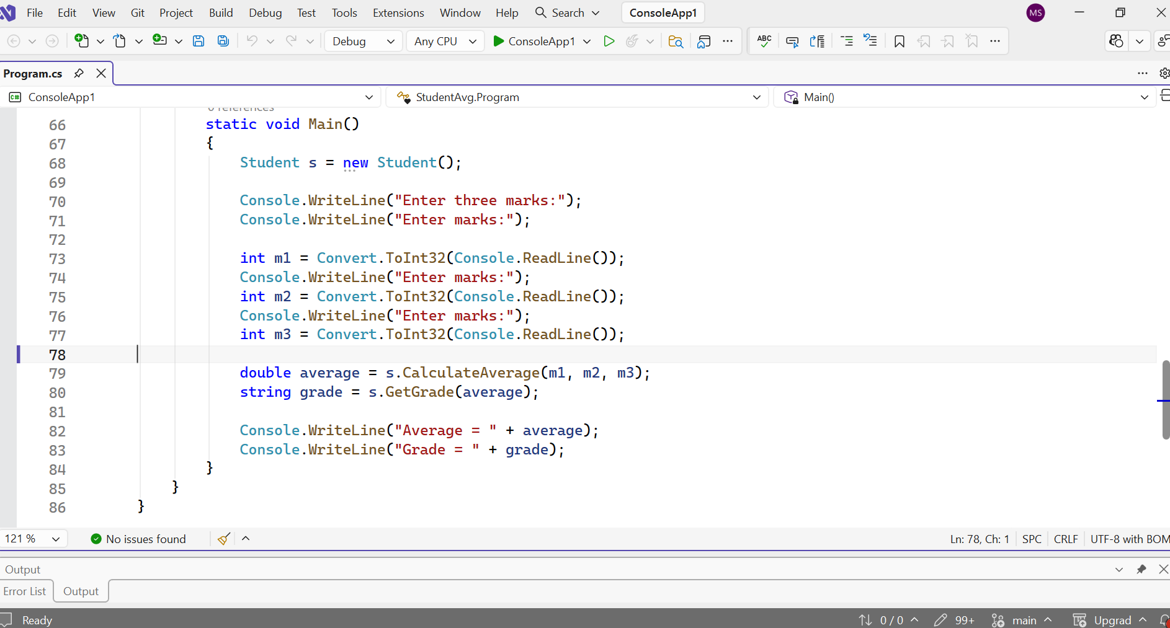
using System.Buffers.Text;
using System.Reflection.Emit;
using System.Runtime.ConstrainedExecution;

using System;

namespace StudentAvg
{
class Student
{
// Method to calculate average
public double CalculateAverage(int m1, int m2, int m3)
{
double avg = (m1 + m2 + m3) / 3.0;
return avg;
}

// Method to get grade using switch case
public string GetGrade(double avg)
{
int gradeCategory = (int)avg / 10;

switch (gradeCategory)
{
case 10:
case 9:
case 8:
return "A";

case 7:
return "B";

case 6:
return "C";

default:
return "Fail";
}
}
}

class Program
{
static void Main()
{
Student s = new Student();

Console.WriteLine("Enter three marks:");
Console.WriteLine("Enter marks:");

int m1 = Convert.ToInt32(Console.ReadLine());
Console.WriteLine("Enter marks:");
int m2 = Convert.ToInt32(Console.ReadLine());
Console.WriteLine("Enter marks:");
int m3 = Convert.ToInt32(Console.ReadLine());

double average = s.CalculateAverage(m1, m2, m3);
string grade = s.GetGrade(average);

Console.WriteLine("Average = " + average);
Console.WriteLine("Grade = " + grade);
}
}
}
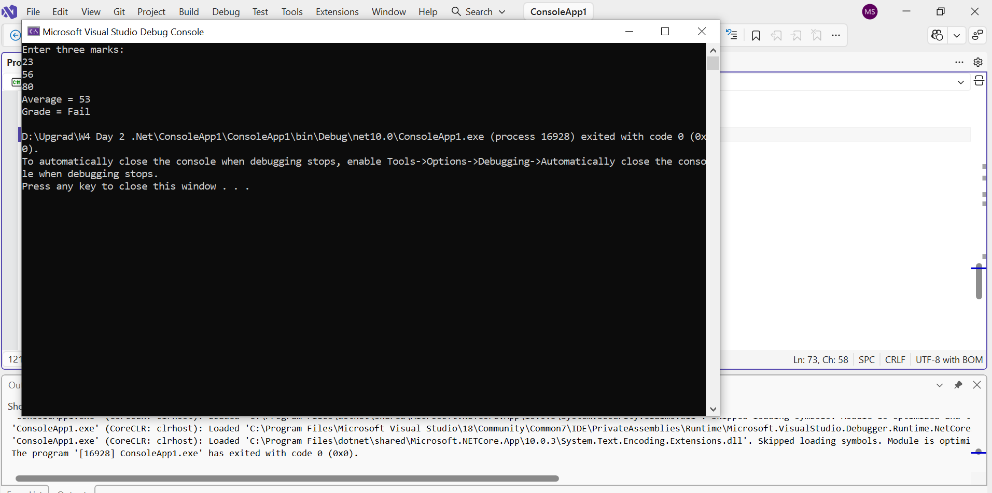

Level-2 Problem 1: Bank Account with Encapsulation
Scenario:
A bank wants to manage customer accounts securely using encapsulation.
Requirements:
1. Create class BankAccount.
2. Private field: balance.
3. Public methods: Deposit(double amount), Withdraw(double amount).
4. Method GetBalance() to return balance.
5. Prevent withdrawal if insufficient balance.
Technical Constraints:
1. Balance must be private.
2. Access balance only through public methods.
3. Use appropriate return types.
Expectations:
Proper use of encapsulation and object-oriented principles.
Learning Outcome:
Understand encapsulation, access modifiers, and secure data handling.
Sample Input:
Deposit 1000, Withdraw 300
Sample Output:
Current Balance = 700

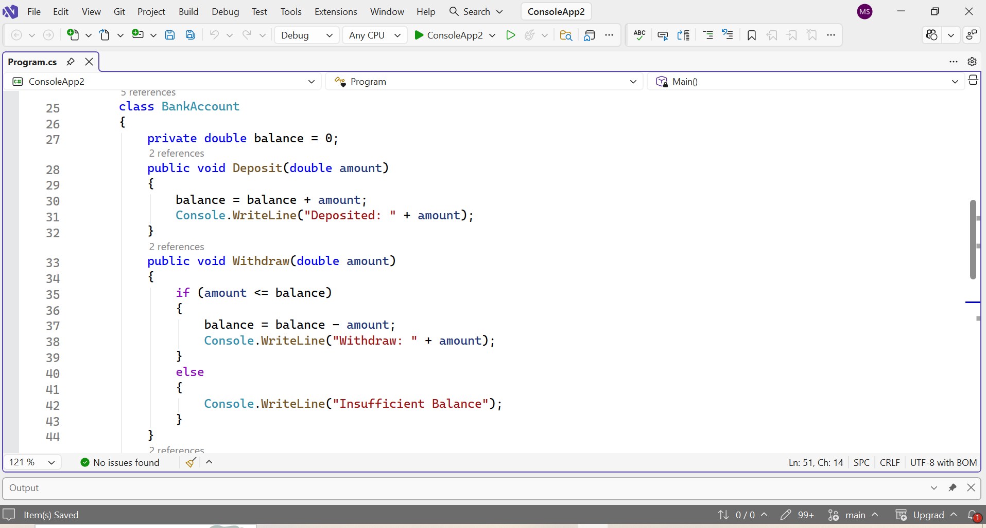

using System;

class BankAccount
{
private double balance = 0;
public void Deposit(double amount)
{
balance = balance + amount;
Console.WriteLine("Deposited: " + amount);
}
public void Withdraw(double amount)
{
if (amount <= balance)
{
balance = balance - amount;
Console.WriteLine("Withdraw: " + amount);
}
else
{
Console.WriteLine("Insufficient Balance");
}
}
public double GetBalance()
{
return balance;
}
}

class Program
{
static void Main()
{
BankAccount account = new BankAccount();

account.Deposit(1000);
account.Withdraw(300);

Console.WriteLine("Current Balance = " + account.GetBalance());
}
}
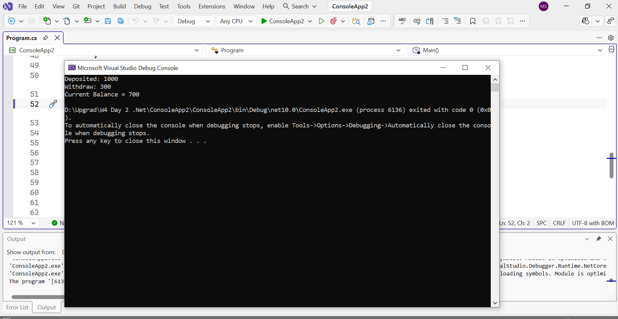

Level-2 Problem 3: Employee Salary Calculator
Scenario:
A company wants to calculate employee salaries using inheritance. All employees have a base salary, but different roles calculate bonuses differently.
Requirements:
1. Create a base class Employee with Name and BaseSalary properties.
2. Create derived classes Manager and Developer.
3. Override a virtual method CalculateSalary().
4. Manager gets 20% bonus, Developer gets 10% bonus.
Technical Constraints:
• Use inheritance and method overriding.
• Apply polymorphism using base class reference.
• Use properties for salary details.
Expectations:
• Demonstrate runtime polymorphism.
• Avoid code duplication.
• Display final calculated salary.
Learning Outcome:
• Understand inheritance hierarchy.
• Implement polymorphism using virtual and override.
• Write reusable and extensible code.
Sample Input:
BaseSalary = 50000
Sample Output:
Manager Salary = 60000, Developer Salary = 55000
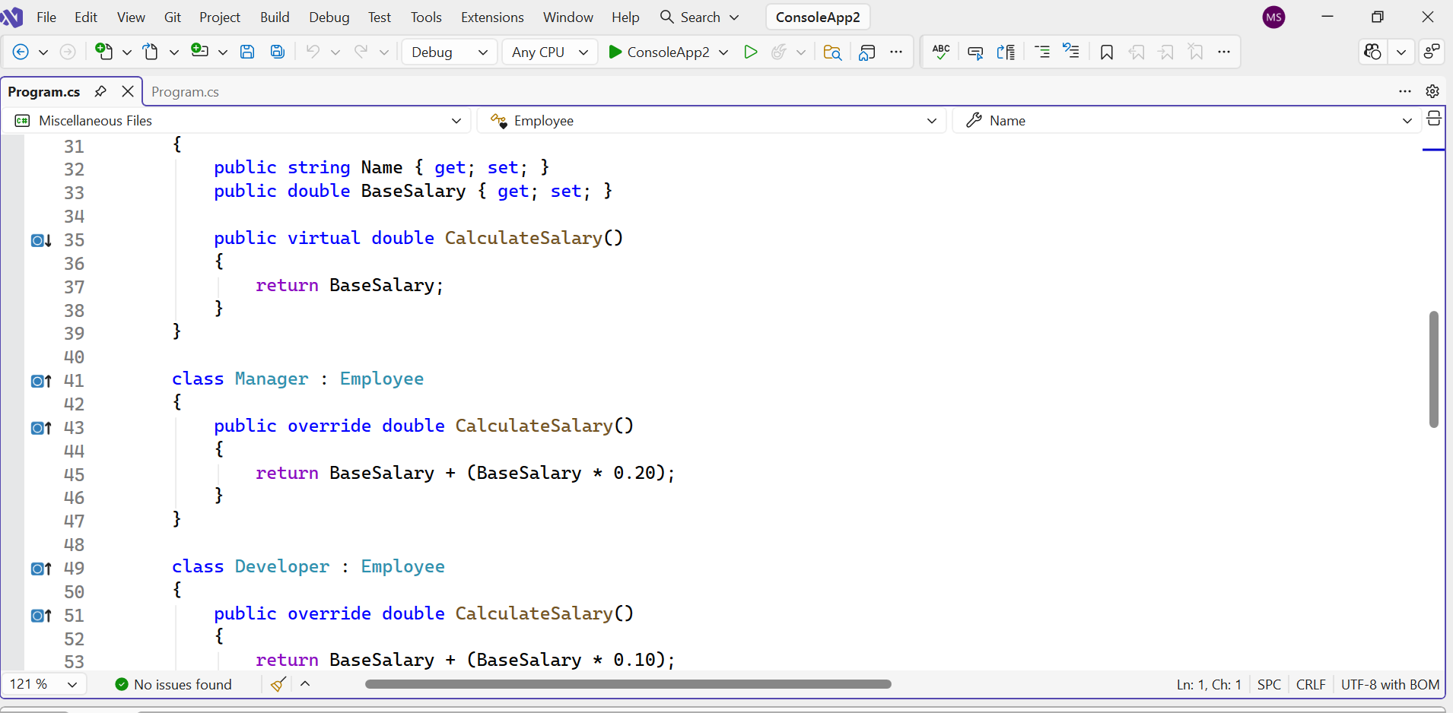
using System.ComponentModel;
using System.Runtime.Intrinsics.X86;

using System;

class Employee
{
public string Name { get; set; }
public double BaseSalary { get; set; }

public virtual double CalculateSalary()
{
return BaseSalary;
}
}

class Manager : Employee
{
public override double CalculateSalary()
{
return BaseSalary + (BaseSalary * 0.20);
}
}

class Developer : Employee
{
public override double CalculateSalary()
{
return BaseSalary + (BaseSalary * 0.10);
}
}

class Program
{
static void Main()
{
double baseSalary = 50000;

Employee manager = new Manager();
manager.BaseSalary = baseSalary;

Employee developer = new Developer();
developer.BaseSalary = baseSalary;

Console.WriteLine("Manager Salary = " + manager.CalculateSalary());
Console.WriteLine("Developer Salary = " + developer.CalculateSalary());
}
}
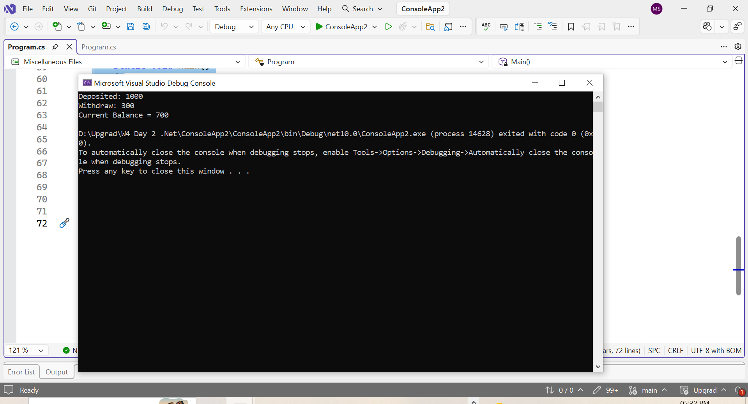
Level-2 Problem 4: Online Shopping Cart System
Scenario:
An e-commerce platform needs a flexible cart system where different product types calculate discounts differently.
Requirements:
1. Create a base class Product with properties Name and Price.
2. Create derived classes Electronics and Clothing.
3. Implement a virtual method CalculateDiscount().
4. Electronics get 5% discount, Clothing gets 15% discount.
5. Use encapsulation to protect price updates.
Technical Constraints:
• Use private fields with public properties.
• Apply inheritance and method overriding.
• Prevent negative price assignment.
Expectations:
• Demonstrate polymorphic behavior in cart processing.
• Apply data validation inside properties.
• Calculate and display final price after discount.
Learning Outcome:
• Combine encapsulation and polymorphism.
• Design extensible product hierarchy.
• Implement business logic in overridden methods.
Sample Input: Electronics Price = 20000
Sample Output: Final Price after 5% discount = 19000
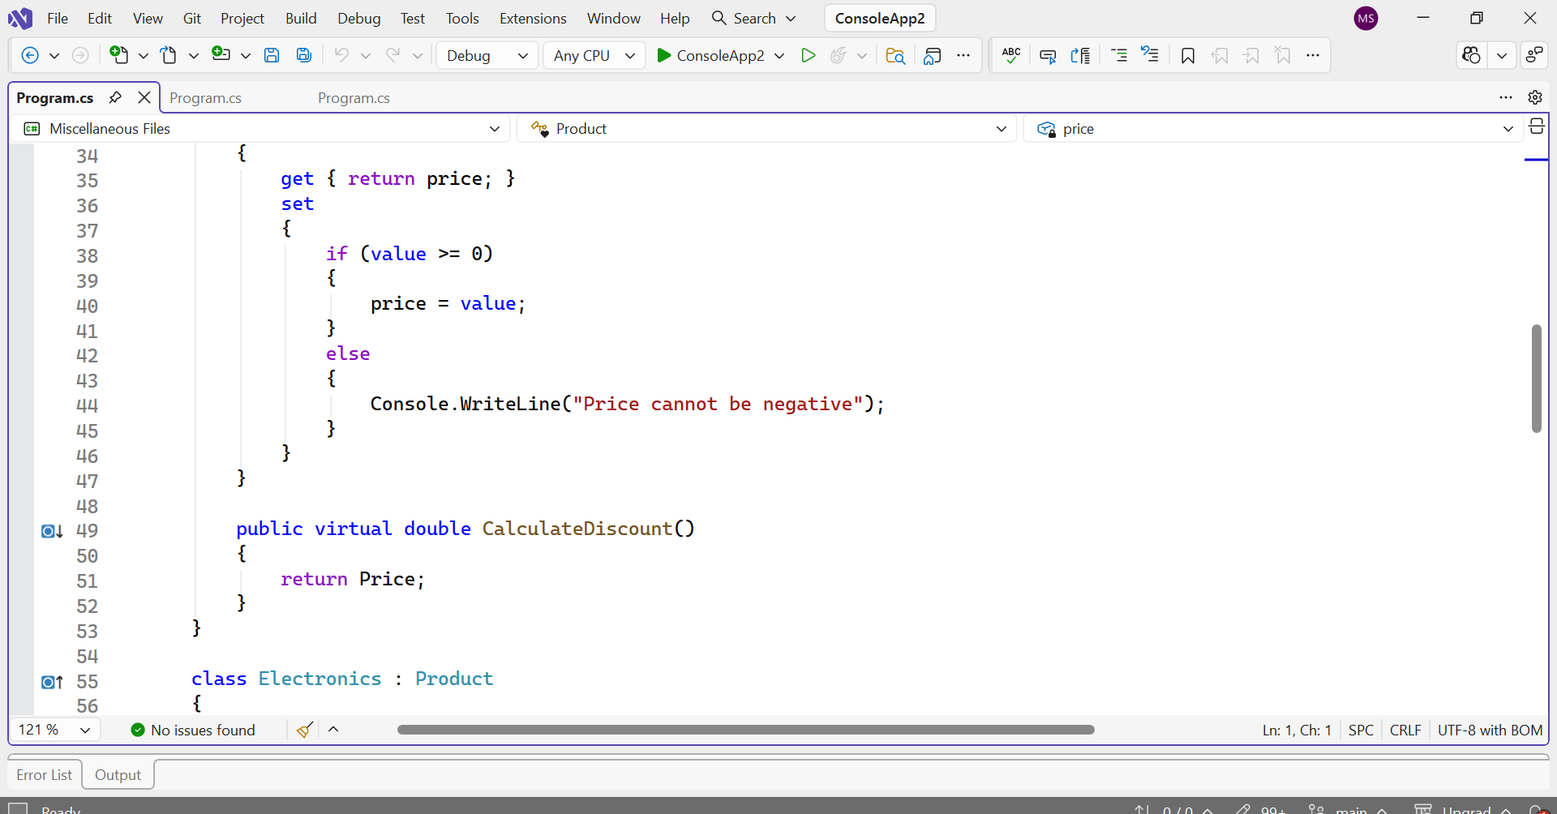

using System;

class Product
{
private double price; // Encapsulation

public string Name { get; set; }

public double Price
{
get { return price; }
set
{
if (value >= 0)
{
price = value;
}
else
{
Console.WriteLine("Price cannot be negative");
}
}
}

public virtual double CalculateDiscount()
{
return Price;
}
}

class Electronics : Product
{
public override double CalculateDiscount()
{
return Price - (Price * 0.05);
}
}

class Clothing : Product
{
public override double CalculateDiscount()
{
return Price - (Price * 0.15);
}
}

class Program
{
static void Main()
{
Electronics e = new Electronics();
e.Name = "Laptop";
e.Price = 20000;

Clothing c = new Clothing();
c.Name = "Shirt";
c.Price = 3000;

Console.WriteLine("Electronics Final Price after 5% discount = " + e.CalculateDiscount());
Console.WriteLine("Clothing Final Price after 15% discount = " + c.CalculateDiscount());
}
}
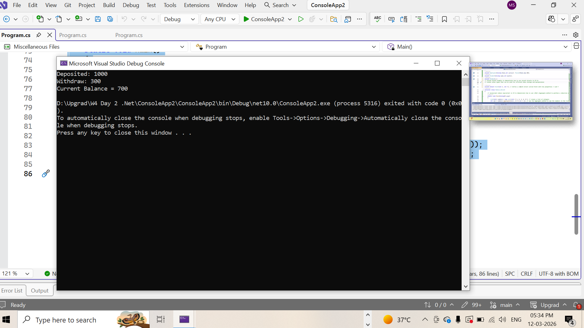

Level-2 Problem 5: Vehicle Rental System
Scenario:
A vehicle rental company wants a system where different vehicle types calculate rental charges differently.
Requirements:
1. Create a base class Vehicle with properties Brand and RentalRatePerDay.
2. Create derived classes Car and Bike.
3. Override CalculateRental(int days) method.
4. Car adds insurance charge of 500 per rental.
5. Bike offers 5% discount on total rental.
Technical Constraints:
• Use encapsulation with proper access modifiers.
• Apply runtime polymorphism.
• Validate number of rental days.
Expectations:
• Use base class reference to call overridden methods.
• Implement clean class hierarchy.
• Display final rental cost.
Learning Outcome:
• Master inheritance and polymorphism.
• Implement real-world OOP scenarios.
• Improve object-oriented design skills.
Sample Input:
Car RentalRatePerDay = 2000, Days = 3
Sample Output:
Total Rental = 6500
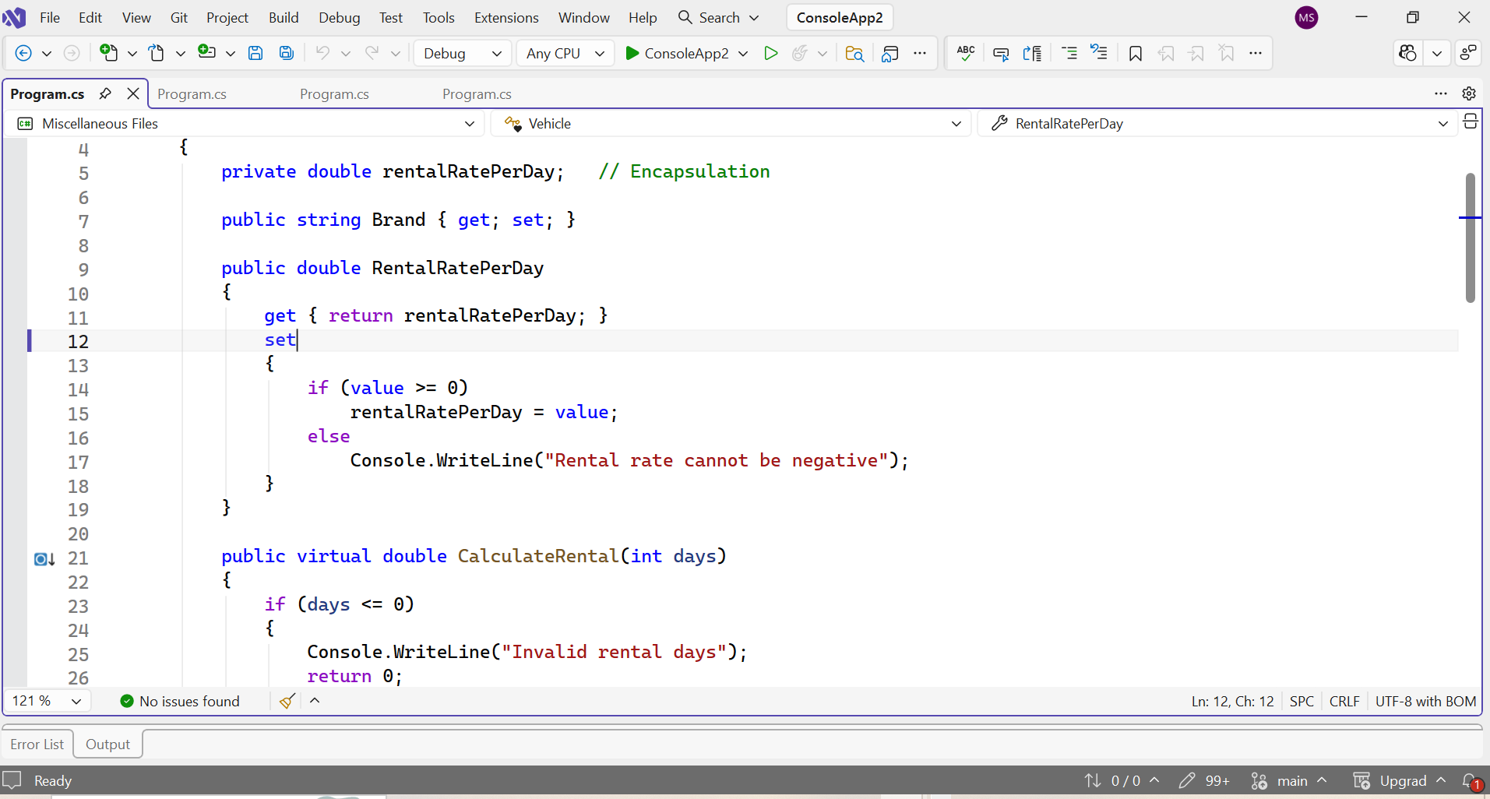
using System;

class Vehicle
{
private double rentalRatePerDay; // Encapsulation

public string Brand { get; set; }

public double RentalRatePerDay
{
get { return rentalRatePerDay; }
set
{
if (value >= 0)
rentalRatePerDay = value;
else
Console.WriteLine("Rental rate cannot be negative");
}
}

public virtual double CalculateRental(int days)
{
if (days <= 0)
{
Console.WriteLine("Invalid rental days");
return 0;
}

return RentalRatePerDay * days;
}
}

class Car : Vehicle
{
public override double CalculateRental(int days)
{
double total = base.CalculateRental(days);
return total + 500; // insurance charge
}
}

class Bike : Vehicle
{
public override double CalculateRental(int days)
{
double total = base.CalculateRental(days);
return total - (total * 0.05); // 5% discount
}
}

class Program
{
static void Main()
{
int days = 3;

Vehicle car = new Car(); // runtime polymorphism
car.Brand = "Toyota";
car.RentalRatePerDay = 2000;

double totalRental = car.CalculateRental(days);

Console.WriteLine("Total Rental = " + totalRental);
}
}
